**Self-made Ethernet board Test Log**

**Author: Haolin LI**

**Phase 1:**Measure/interpret the signals and replace the DP83848C

Results:

the Green LED lit several times, and then again didn’t light anymore.

From the Microchip forum, I knew that someone has made the board three times to get it work. And according to the forum, the capacitors are crucial.

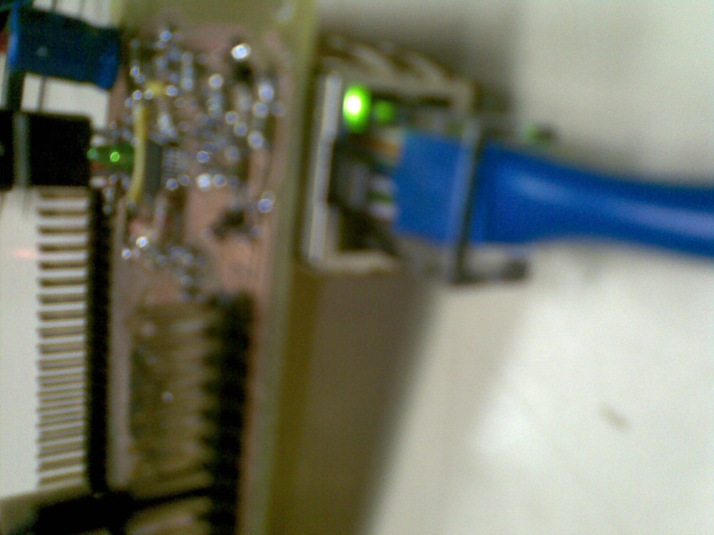

**Phase 2: Debug and configure/read registers manually**

1. **Change the clock**

Considering this malfunction might be caused by the external clock, I tried to use the internal 8 MHz clock.

In “ETHPIC32IntMac.c”

_LinkReconfigure(void) is unsuccessful. Line 277

* The ETH_LINK status is down

Reason:

In “ETHPIC32ExtPhy.c”

EthPhyNegotiationComplete returns “ETH_RES_NEGOTIATION_ACTIVE “ which means negotiation is ongoing and not done.

An observation:

MACInit() is invoked once in StackInit(),

In MACInit() there is a while-loop to make sure the MACInit will succeed, however in the original source code the “break” will break the while-loop, which implies no success is guaranteed for MACInit().

* if(linkStat==ETH_LINK_ST_UP) break; // break the loop when the link is established

Try:

Keep it negotiating until it returns “ETH_RES_OK”. After software reset the GREEN led is back:

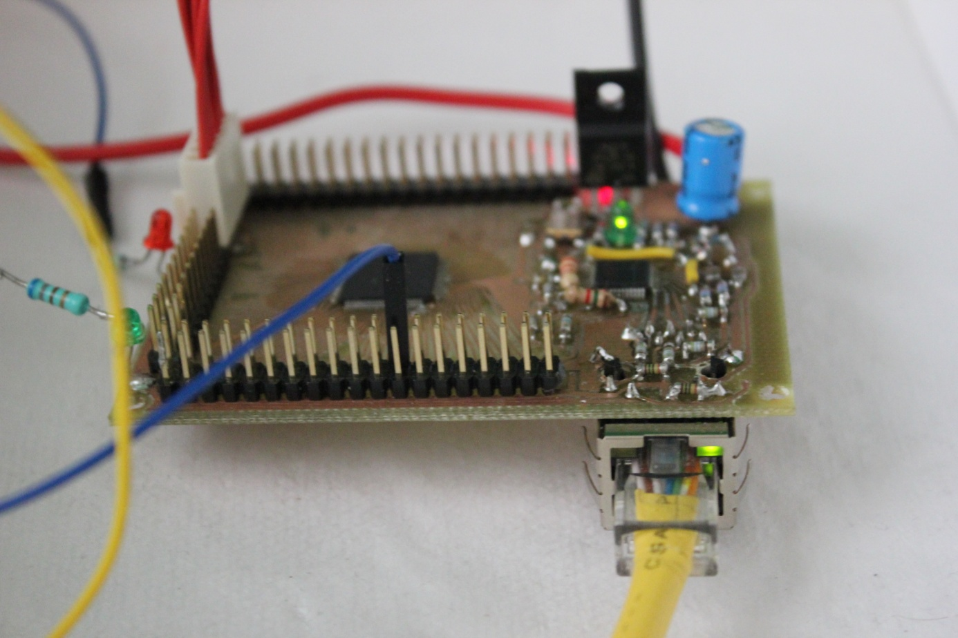

linkFlags=0x0000051F = ETH_OPEN_DEFAULT| ETH_OPEN_RMII -> OK

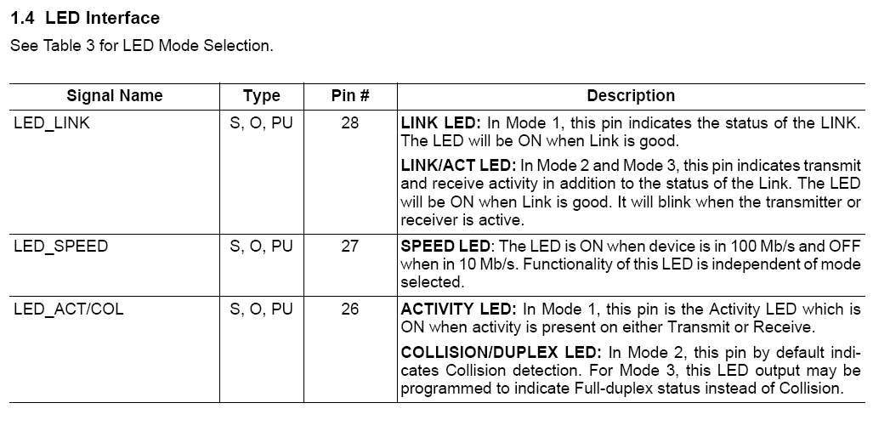

Results:

The LINK was always down no matter which mode was configured.

Temporal Conclusion:

Try to find out the differences between the self-made board and the Ethernet Starter Kit in terms of the layout of PCB, the values and positions of resistors and capacitors. What I am thinking all the time is there shouldn’t have been so many differences if the circuit is the same.

|  |  |  |
| --- | --- | --- |
|  | PIC32 Ethernet Starter Kit | Self-made board |
| Debug/Program | PIC32MX4XX as USB-debug tool | PICkit3 |
| Oscillator | 8MHz XT | 50MHz external clock or 8MHz internal clock |
| Dimensions | Smaller resistors etc.  Smaller distance |  |
|  |  |  |

I’ve checked the clock output of PIC32, which is almost 80MHz => Clock is correctly configured

The MDC of DP83848C (**MANAGEMENT DATA CLOCK)** is almost 20MHz (< maximum 25MHz) => reasonable

1. the PIC32 might be damaged during soldering
2. the PICkit3
3. the PCB needs some adjustment
4. Next time, before soldering the DP83848C the PIC32 needs a complete test
5. **Use external 8MHz crystal**
6. Use the same code for PIC32_ESK, no link is established

|  |  |
| --- | --- |
| Pin |  |
| ETXEN(2) | LOW |
| ETXDO(2) | LOW |
| ETXD1(2) | LOW |
| INT3/SCL1/RA14 | HIGH |
| ERXD0(2) | LOW |
| ERXD1(2) | LOW |
| ERXERR | LOW |
| ECRS_DV | LOW |
| EMDC | 20MHZ |
| EMDIO | LOW |
|  |  |
|  |  |
|  |  |

1. Using the same modified code as in step 2 gave the same result
2. **Test the PIC32 itself**

**Phase 3**: Change circuits

When shifting to another board with the same PIC and DP83848, the code works and the board functions well.

**Conclusion:**

The PIC was not correctly soldered or some pins are short-circuited by mistake. The code is ok.

This part is temporally accomplished!

**Phase 4: Alternatives**

<http://www.digilentinc.com/Products/Detail.cfm?NavPath=2,396,986&Prod=CEREBOT-MX7CK>

Kind of strange, only two companies including Microchip self produce the Ethernet developing board with PIC32MX795F512L, but a lot with ENC-Ethernet chip like ENC28J60, ENC624J600 etc.

Comparison:

ENC-chip: <http://www.microchip.com/wwwproducts/Devices.aspx?dDocName=en541877>

DP83848C maximal 25MHz

**What have we learned from this process?**

Even though it has taken us about 3 weeks to solve this problem, and a lot of code and datasheets have to been read, we still have got something in return:

We know the source code much better => we know how to set the different modes of the DP83848, like 10Mbps, 100Mbps, full duplex and half duplex.

No pain no gain!